Mounting an NFS File System (Windows)

- On Windows, Install the NFS client.

  - Open the Control Panel and click Programs.
  - Click Turn Windows features on or off.
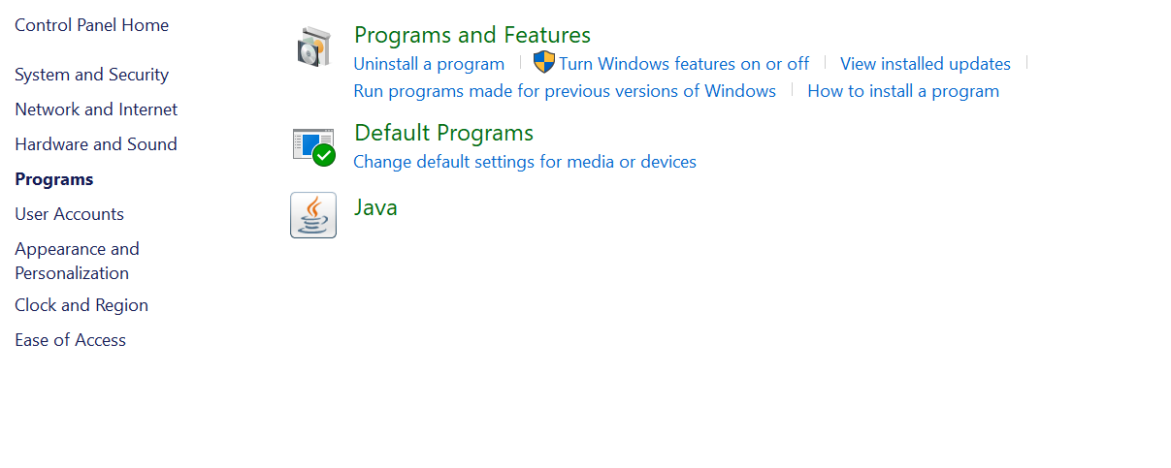
  - Display Services for NFS list, select Administrative Tools and Client for NFS, and click OK.

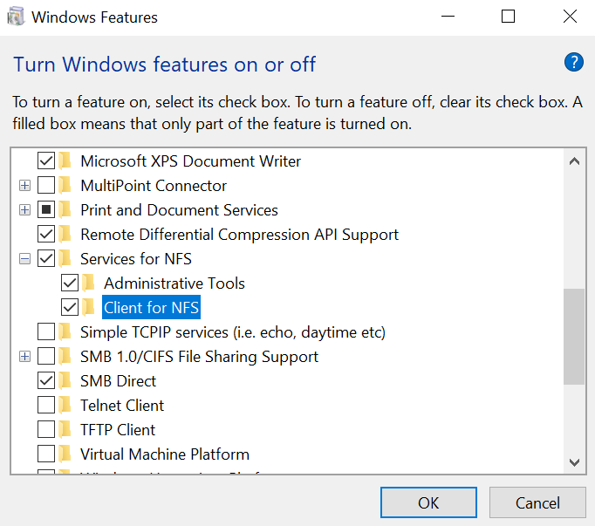

- Modify the NFS transfer protocol.
  - Go to Control Panel > System and Security > Administrative Tools > Services for Network File System (NFS).
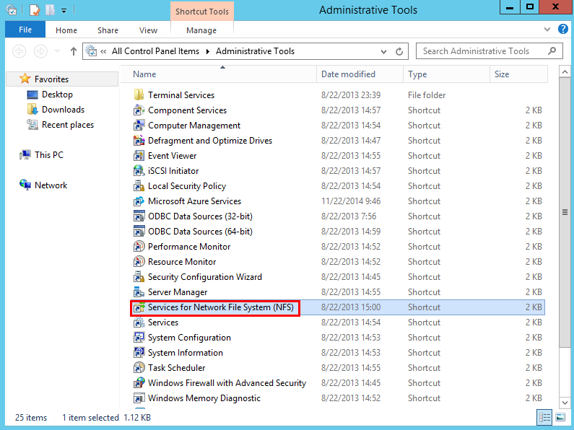
  - Right-click Client for NFS, choose Properties, change the transport protocol to TCP, and select Use hard mounts, as shown in the figure.
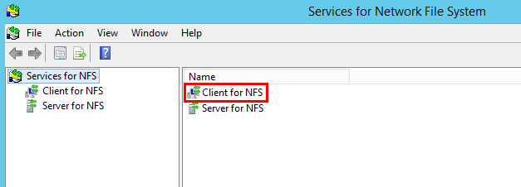
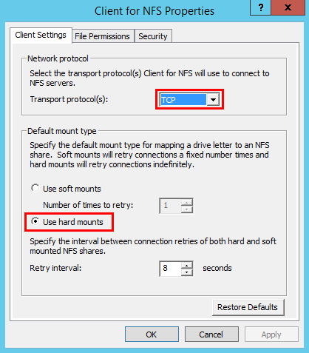
- Run the following command in the Command Prompt of Windows (X is the drive letter of the free disk).

mount -o nolock -o casesensitive=yes IP address:/! X:

You can find the IP address on the SFS console of Huawei Cloud.
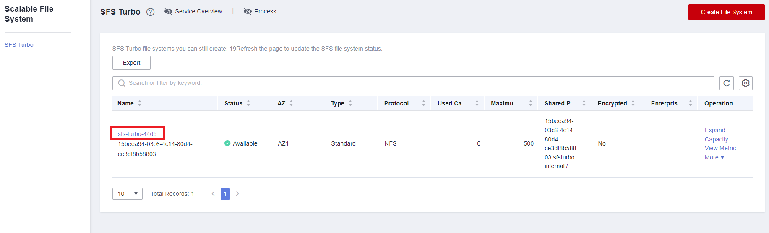
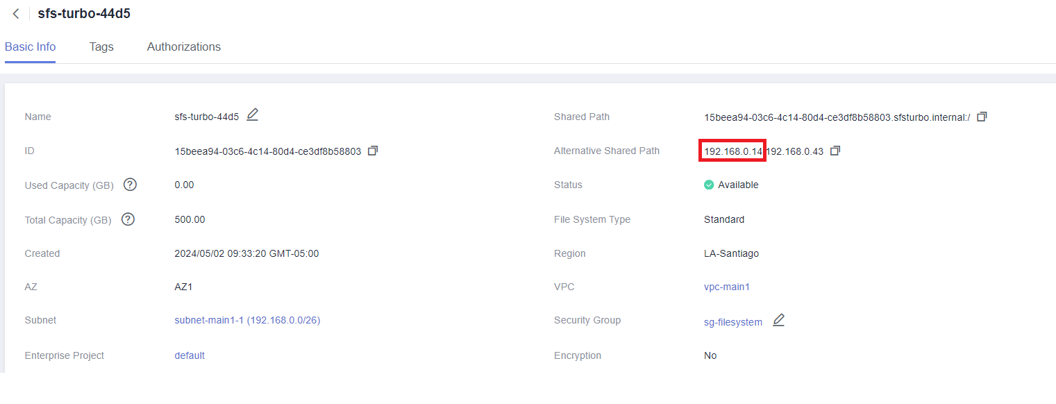

- After the file system is mounted successfully, you can view the mounted file system on the This PC window, as shown in the figure.
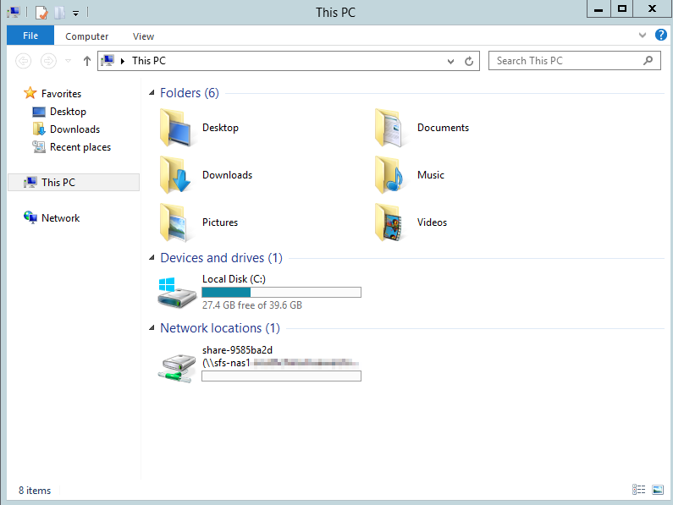

Mounting a File System Automatically

File system mounting information may be lost after an ECS is restarted. You can configure automatic mounting for the ECS to avoid the mounting information loss.
- Before mounting the file system, create a script named auto_mount.bat, save the script to a local host, and record the save path. The script contains the following content:

mount -o nolock -o casesensitive=yes IP address:/! X:
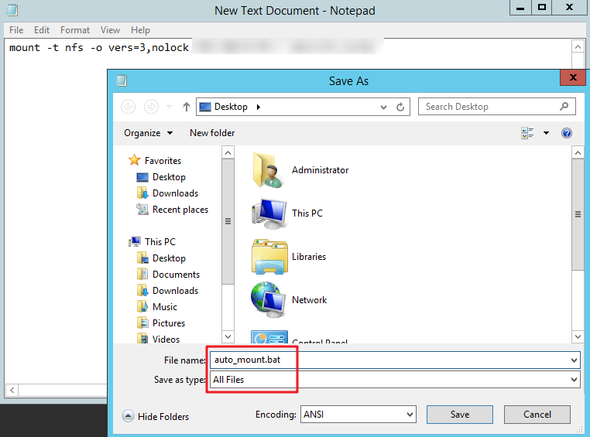
NOTE: This .bat script cannot be stored in the same path of step 2, that stores the .vbs file. For example, the .bat script could be stored in C:\test\.

- Create a .txt file whose name is XXX.vbs and save the file to the directory C:\Users\User\AppData\Roaming\Microsoft\Windows\Start Menu\Programs\Startup. The file contains the following content:

set ws=WScript.CreateObject("WScript.Shell")
ws.Run "Local path and script name of the auto_mount.bat script /start", 0

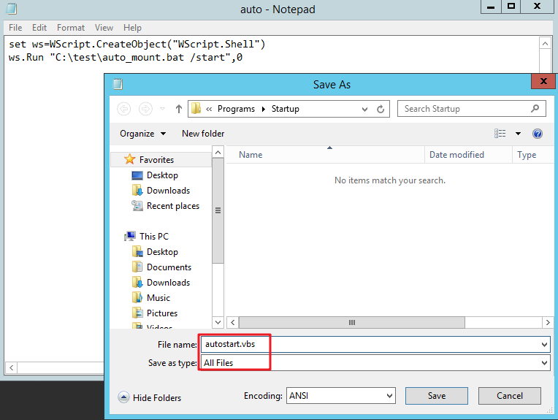

- After the task is created, you can restart and check whether the configuration is successful. After the configuration is successful, the file system automatically appears in This PC.

